Project Description:

In this SQL project, we aim to analyze login attempts and employee information from a database. We will use SQL queries to retrieve specific data related to failed login attempts, login attempts on specific dates, employee departments, and more.

Retrieve After Hours Failed Login Attempts:

To retrieve failed login attempts that occurred after business hours, we can use the following SQL query:

sql

SELECT *

FROM log_in_attempts

WHERE login_time > '18:00:00' AND success = 0;

This query selects all records from the log_in_attempts table where the login_time is after 18:00:00 (end of business hours) and the success column indicates a failed login attempt (success = 0).

Retrieve Login Attempts on Specific Dates:

To retrieve login attempts on specific dates, such as '2022-05-09', we can use the following SQL query:

sql

SELECT *

FROM log_in_attempts

WHERE login_date = '2022-05-09';

This query selects all records from the log_in_attempts table where the login_date is '2022-05-09', indicating login attempts made on that specific date.

Retrieve Login Attempts Outside of Mexico:

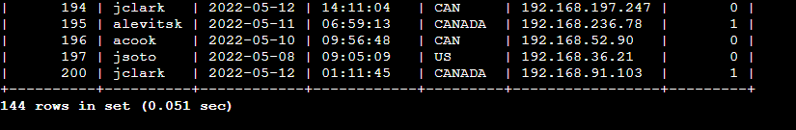

To retrieve login attempts that did not originate in Mexico, we can use the following SQL query:

sql

SELECT *

FROM log_in_attempts

WHERE NOT country LIKE 'MEX%';

This query selects all records from the log_in_attempts table where the country does not start with 'MEX', effectively retrieving login attempts that did not originate in Mexico.

Retrieve Employees in Marketing:

To retrieve employees in the Marketing department, we can use the following SQL query:

sql

SELECT *

FROM employees

WHERE department = 'Marketing';

This query selects all records from the employees table where the department is 'Marketing', providing information about employees in the Marketing department.

Retrieve Employees in Finance or Sales:

To retrieve employees in the Finance or Sales department, we can use the following SQL query:

sql

SELECT *

FROM employees

WHERE department = 'Finance' OR department = 'Sales';

This query selects all records from the employees table where the department is either 'Finance' or 'Sales', giving information about employees in these departments.

Retrieve All Employees Not in IT:

To retrieve all employees not in the Information Technology department, we can use the following SQL query:

sql

SELECT *

FROM employees

WHERE NOT department = 'Information Technology';

This query selects all records from the employees table where the department is not 'Information Technology', providing information about employees in departments other than IT.

Summary:

Through SQL queries, we retrieved information about login attempts, including failed attempts after business hours, attempts on specific dates, and attempts outside of Mexico. Additionally, we retrieved employee information based on department, including employees in Marketing, Finance, and Sales, as well as those not in the IT department. These queries allow for effective analysis and management of login activities and employee data within the organization.